Create EC2 Instance

Login to your LAB and click on EC2 so you will be redirected to EC2 Dashboard

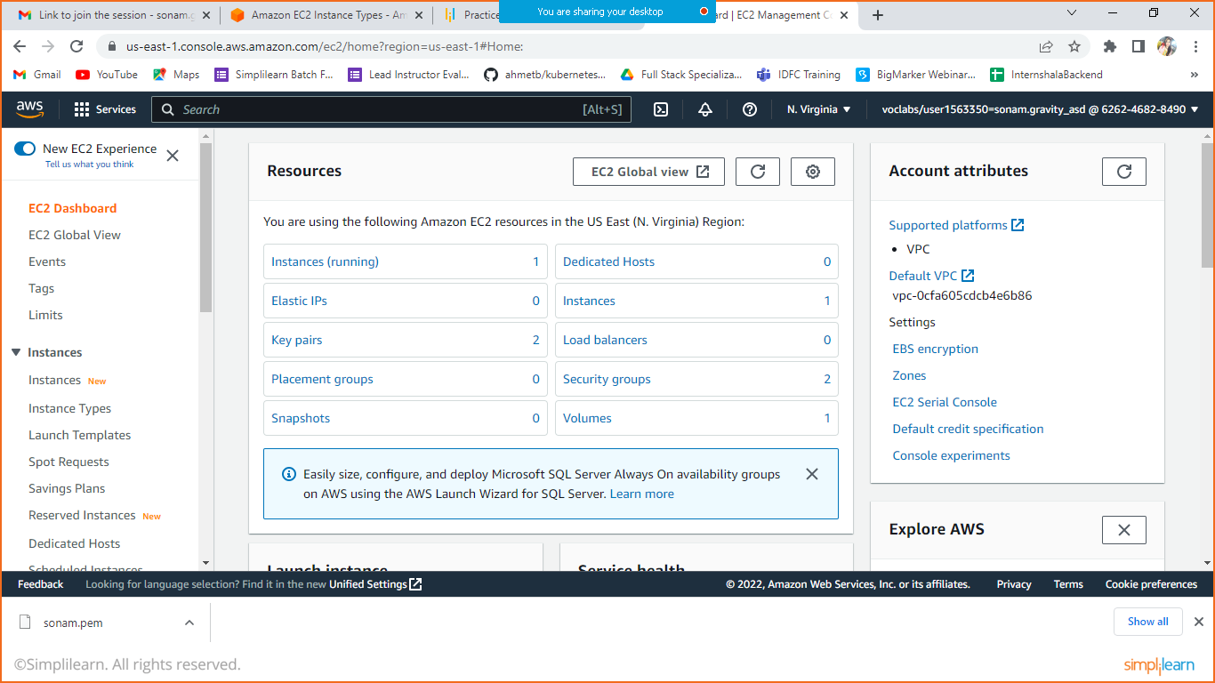

Scroll down so you will get the option to launch your instance.

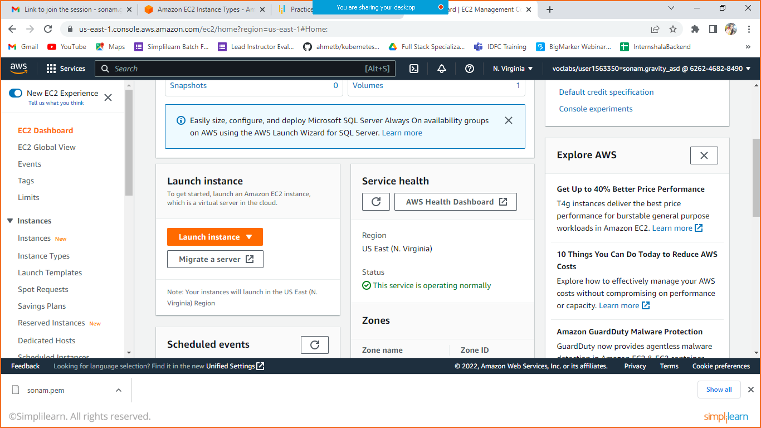

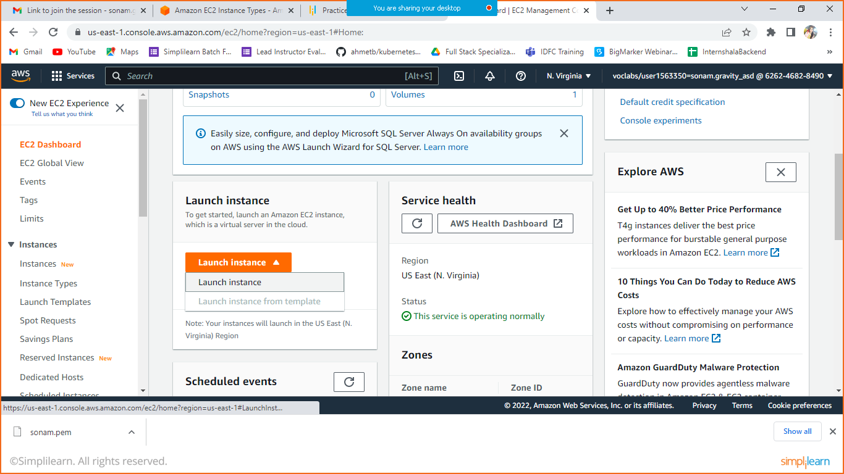

Click on launch instance.

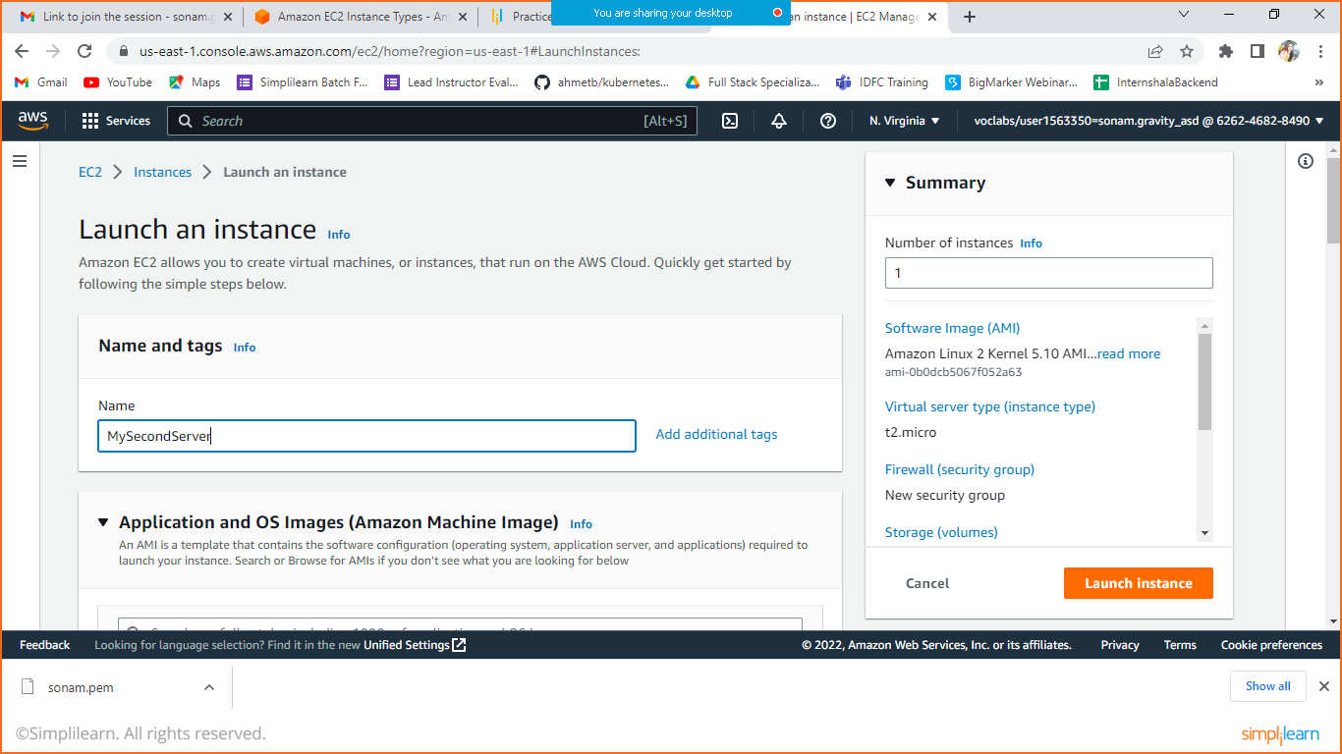

Enter the name.

Select AMI of AWS linux platform. This is selected by Default.

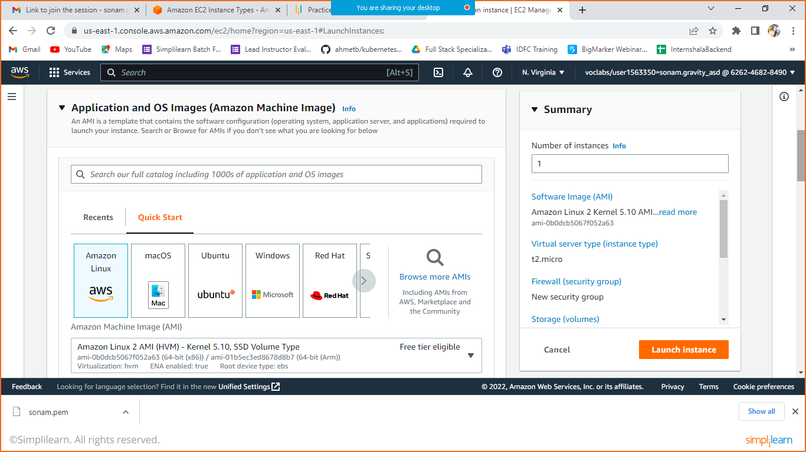

Select instance type (t2.micro- selected by default)

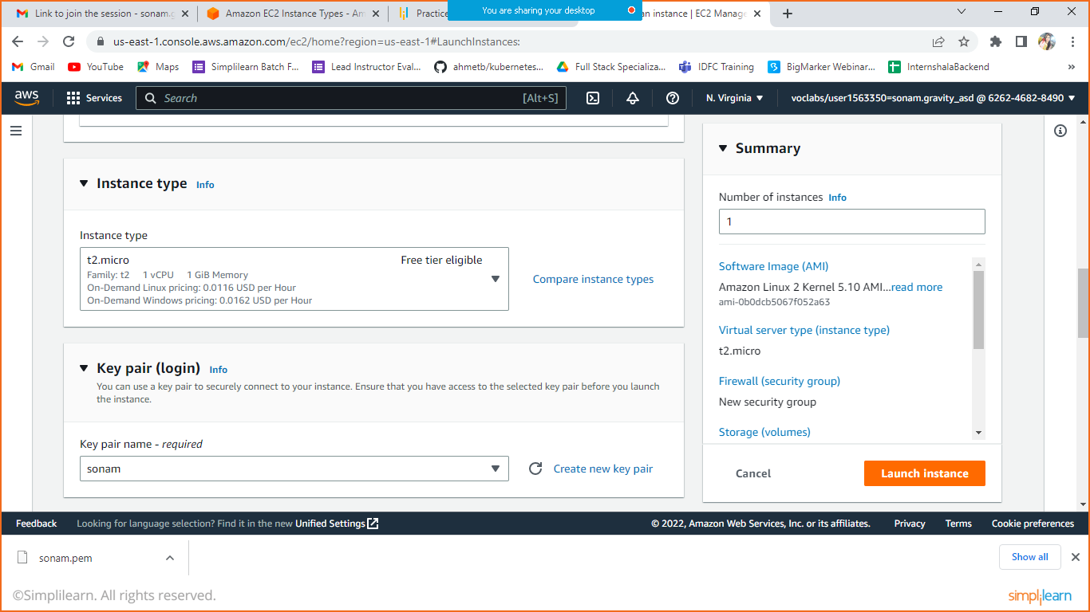

Also Key pair is very important. So for the very first time create a new key pair, later we can use the same as well. When you create a new key pair it will the download the same in your system. Save it to use later. With the help of that pem file you can connect your system with this server created.

**Click on create new key pair.**

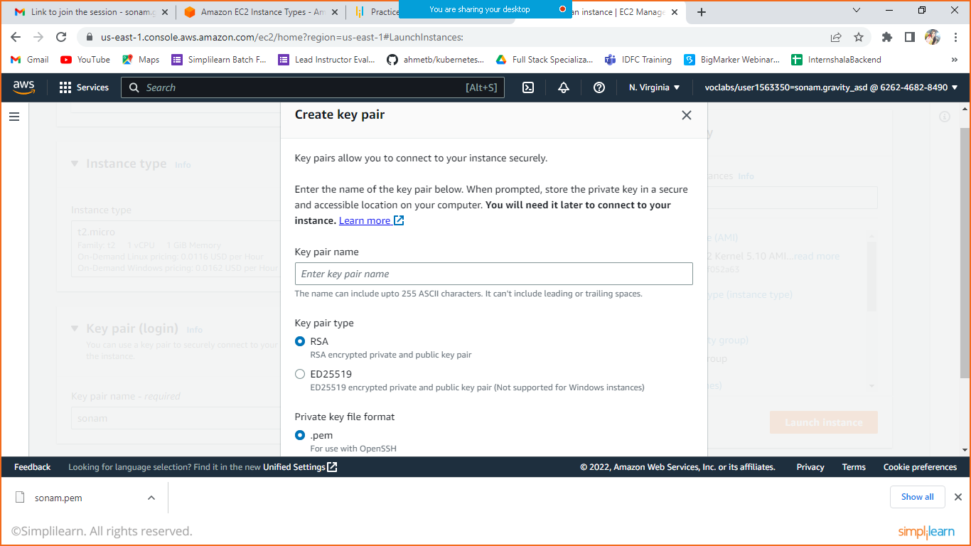

By Default Network setting is having one security rule available for SSH, if you want to add more then click on edit.

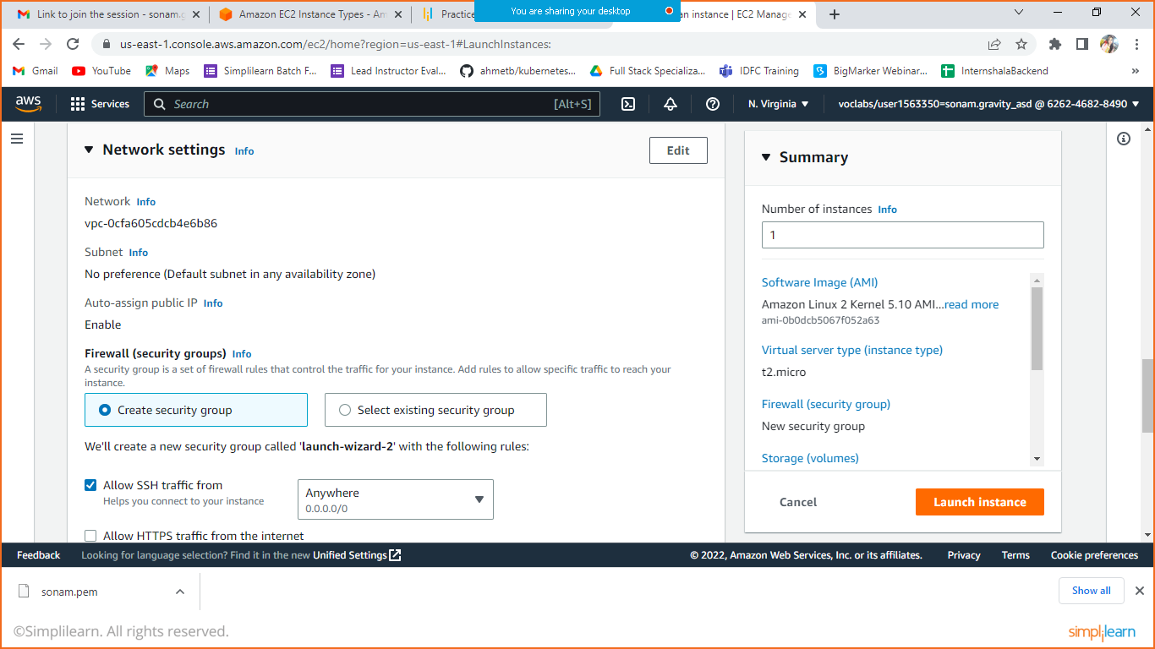

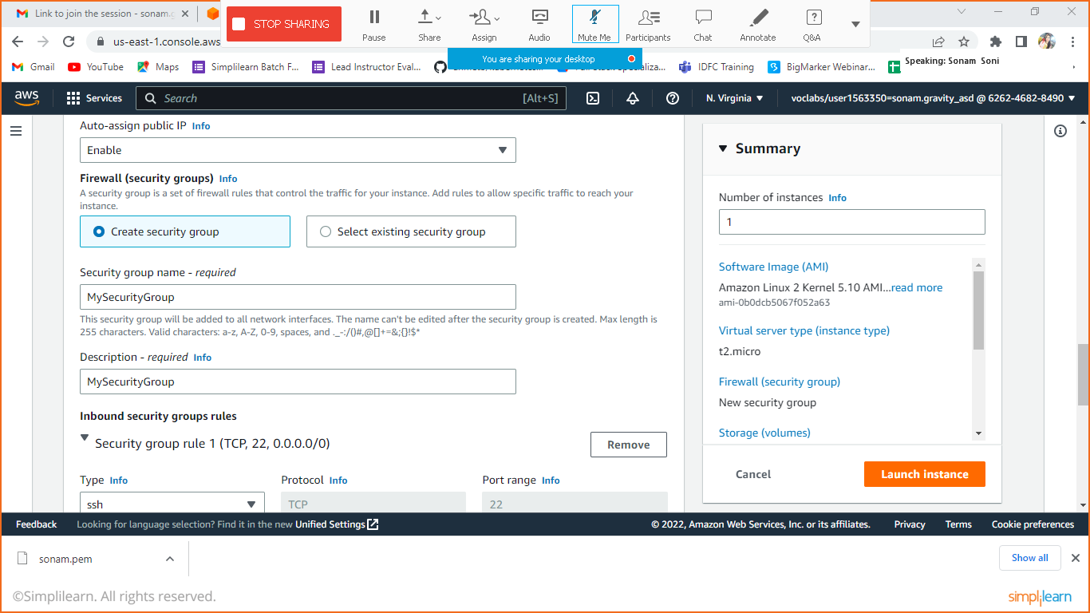

Let’s add some Rule.

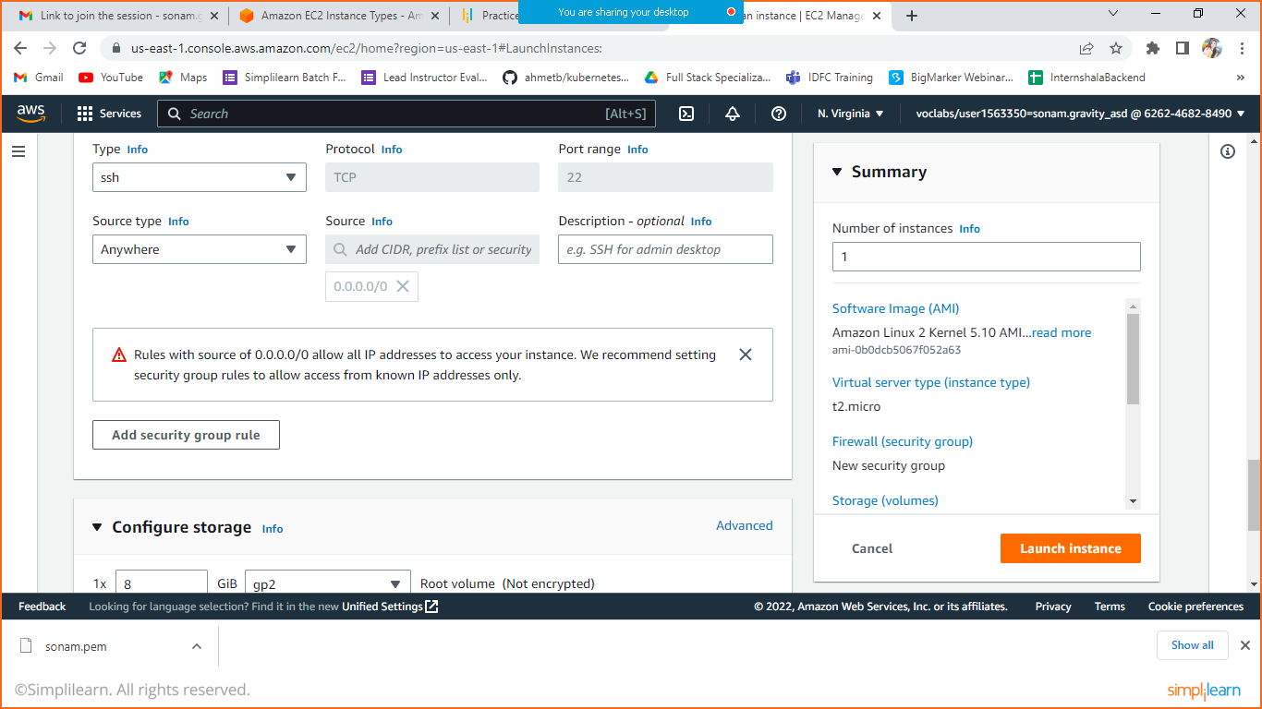

Click on add security Group Rule.

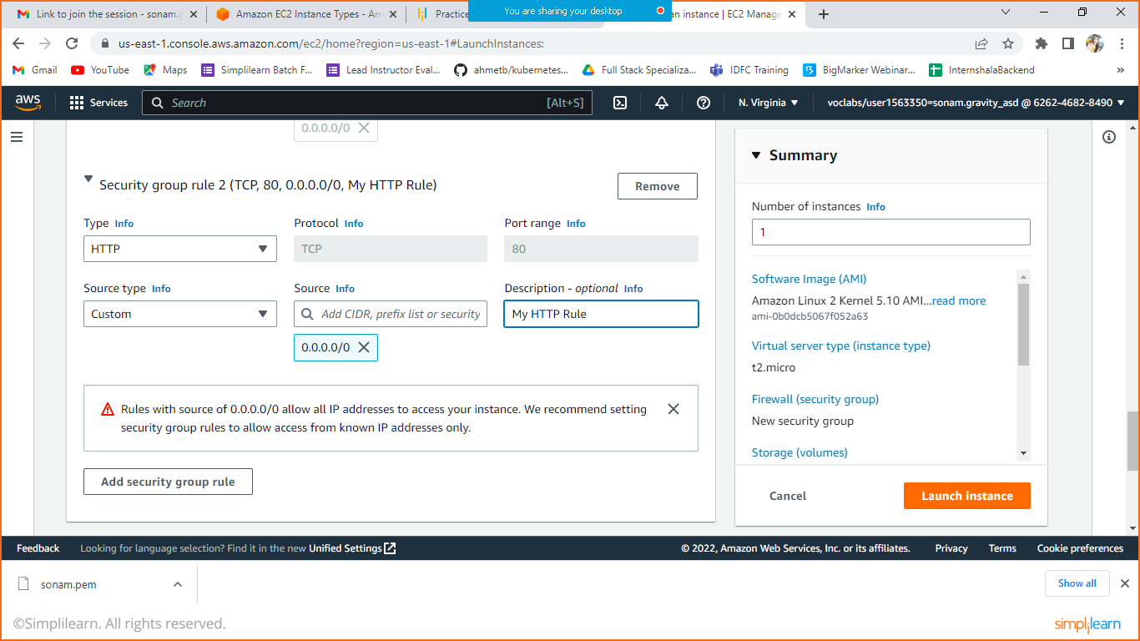

If you want to add more again click on add security group rule. If you want to remove the rule then click on Remove button visible in available screenshot.

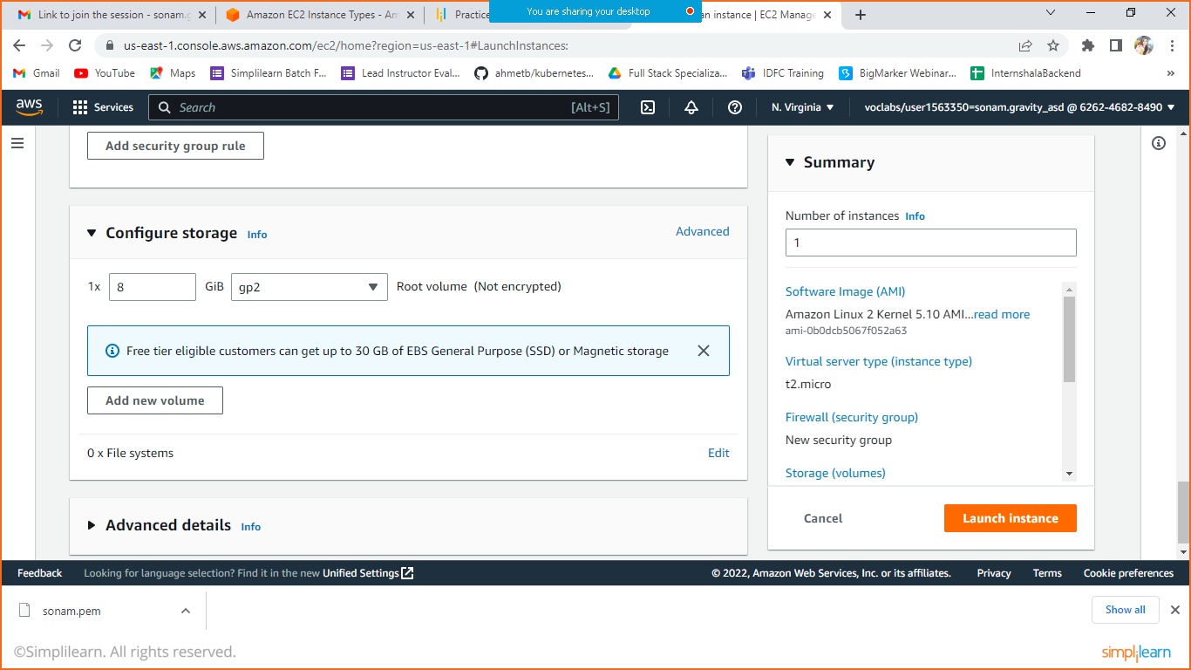

You can add size more if required. If any volume which is externally we want to attach then we can click on Add New volume, we will do it later.

Check the Summary in the Right hand side if everything is Ok then click on Launch Instance.

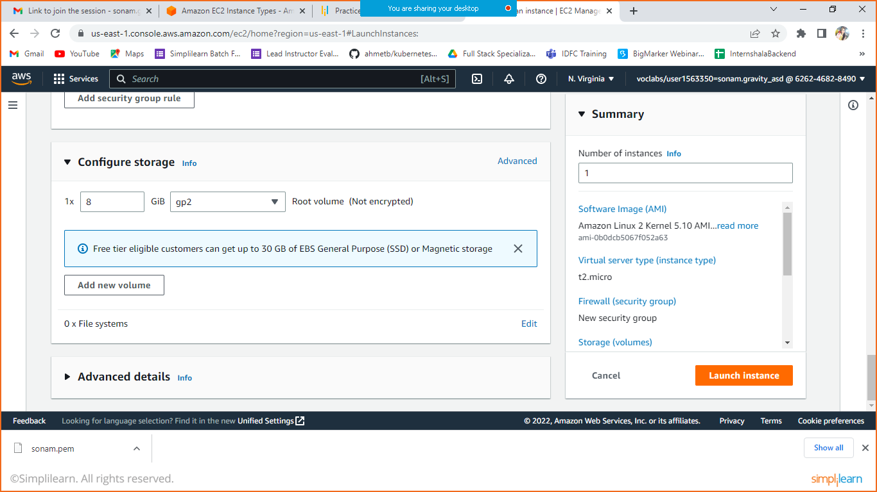

Click on launch Instance.

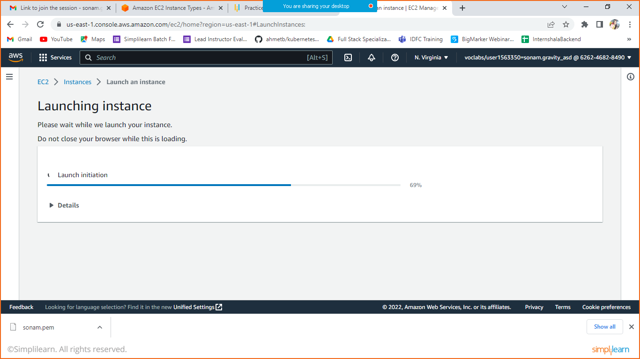

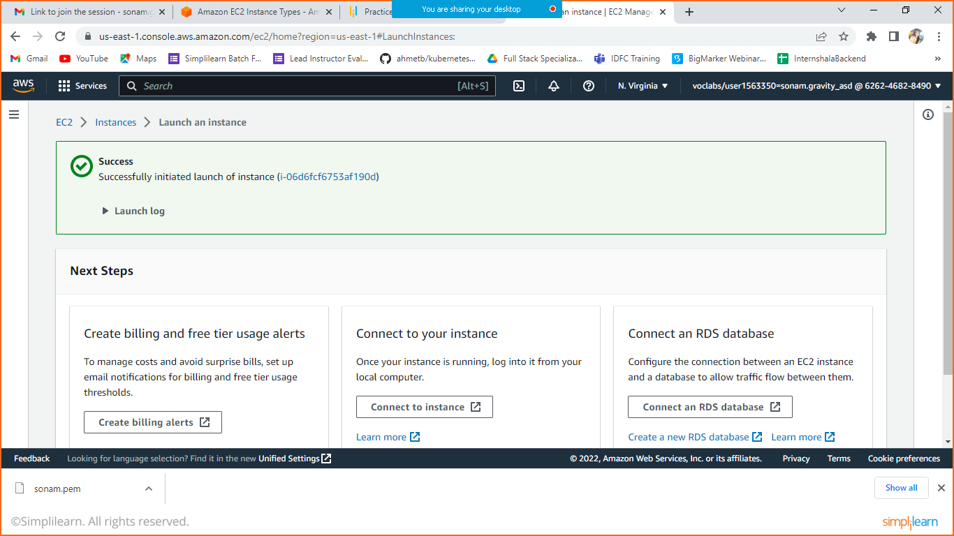

Click on EC2 option where you can see the running instances.

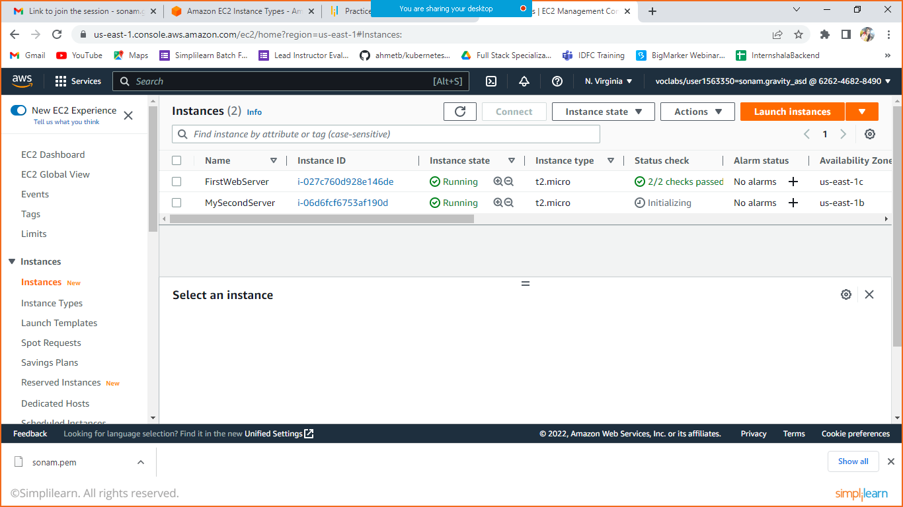

You can see the secondServer initializing.

Click on instance Id to check more details.

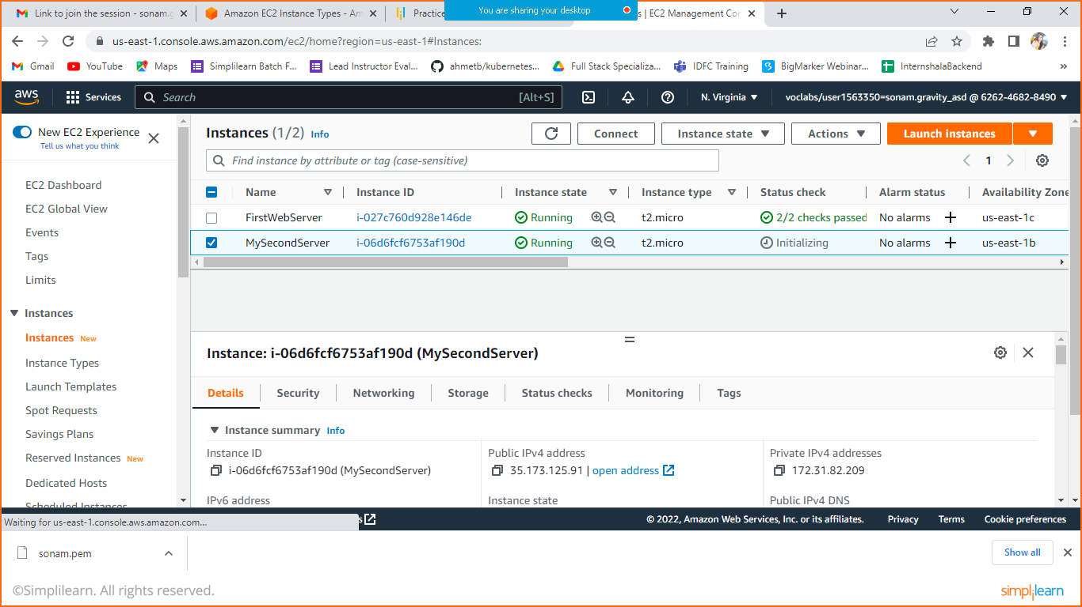

Select the instance and click on Connect.

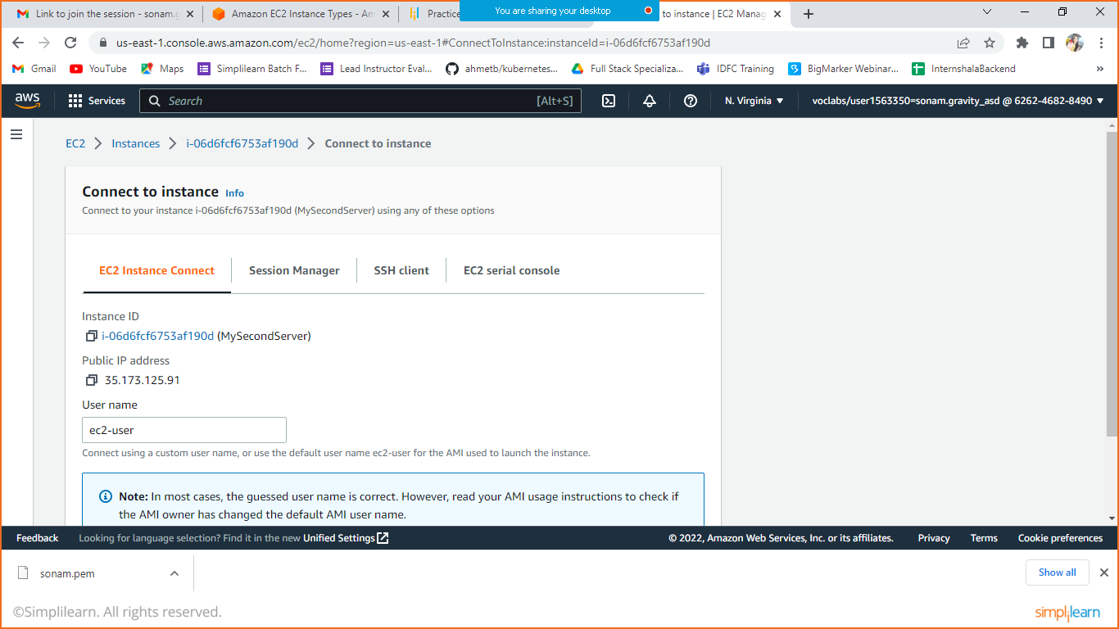

Scroll down where you can see the connect option

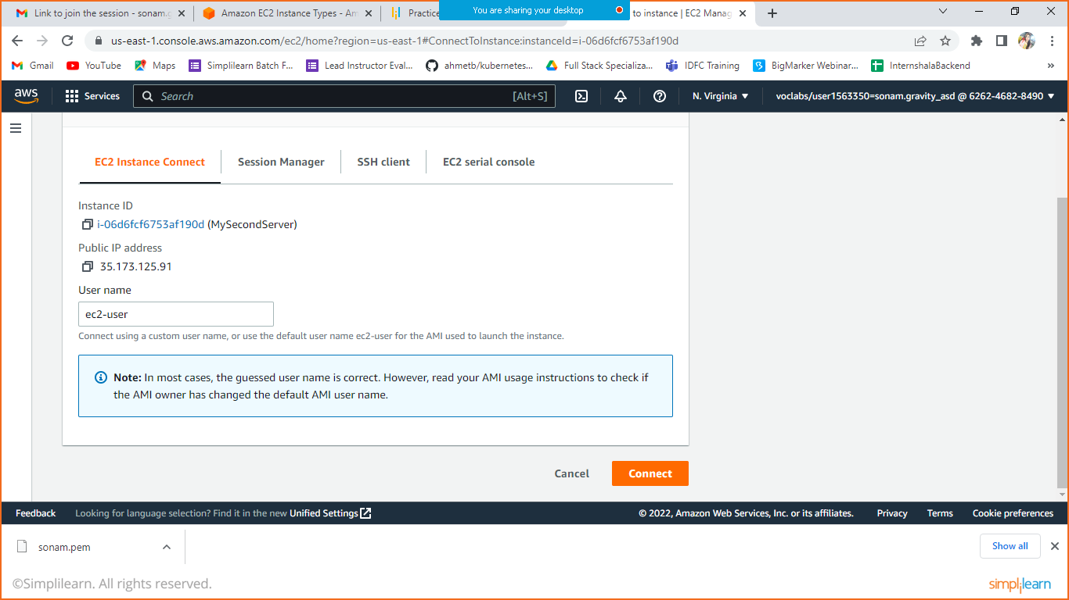

Click on connect and then you will be redirected to AWS console.

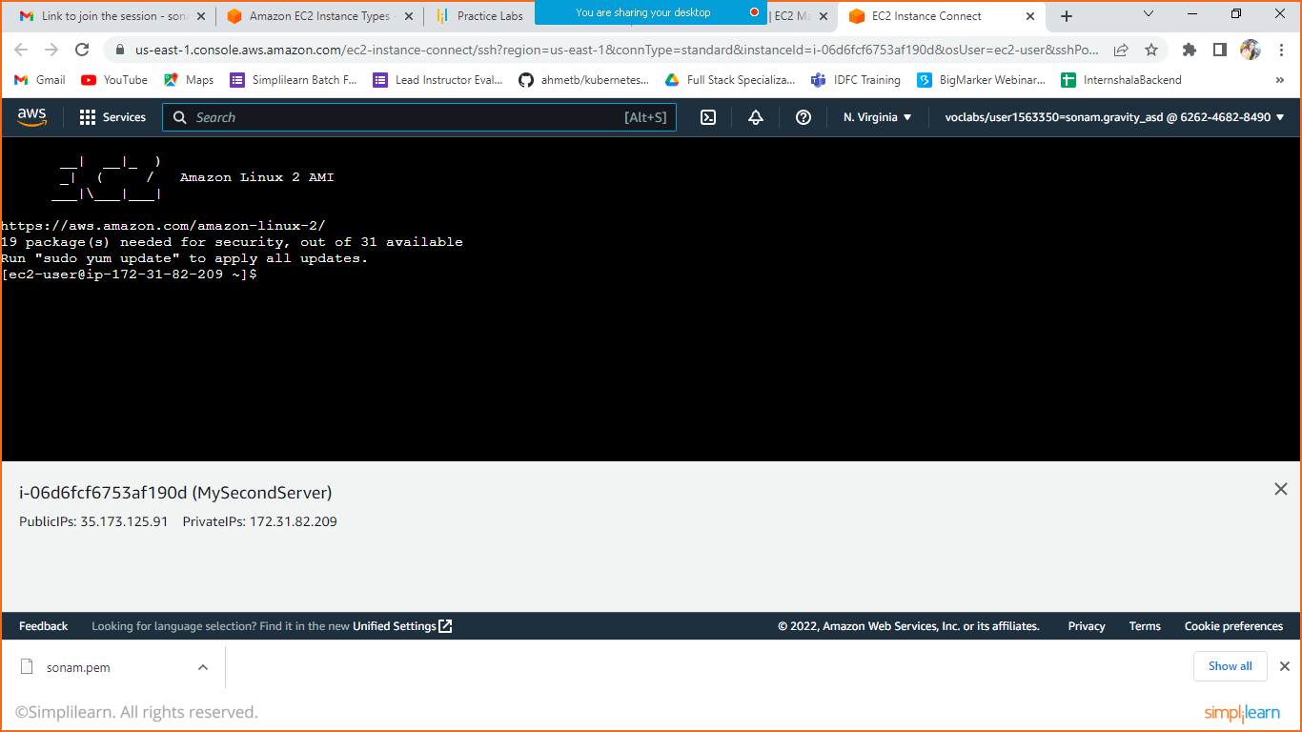

Let’s install Httpd server by executing below command.

Yum install httpd –y

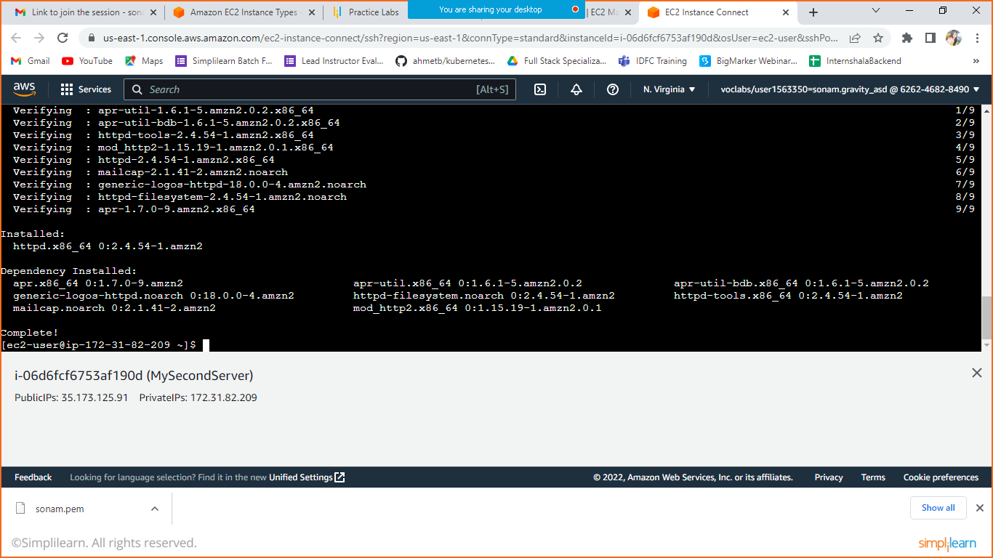

Navigate to the folder /var/www/html

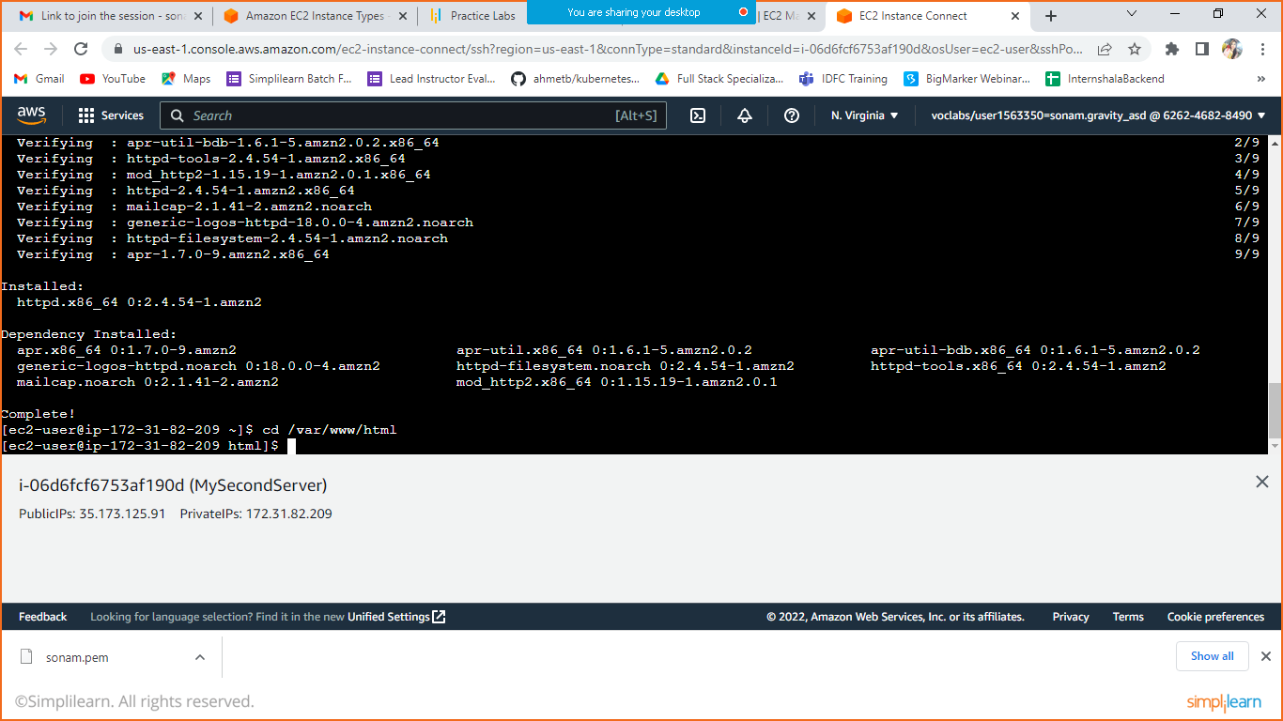

Let’s create a HTML file

sudo vi index.html

Press I and edit below mentioned code

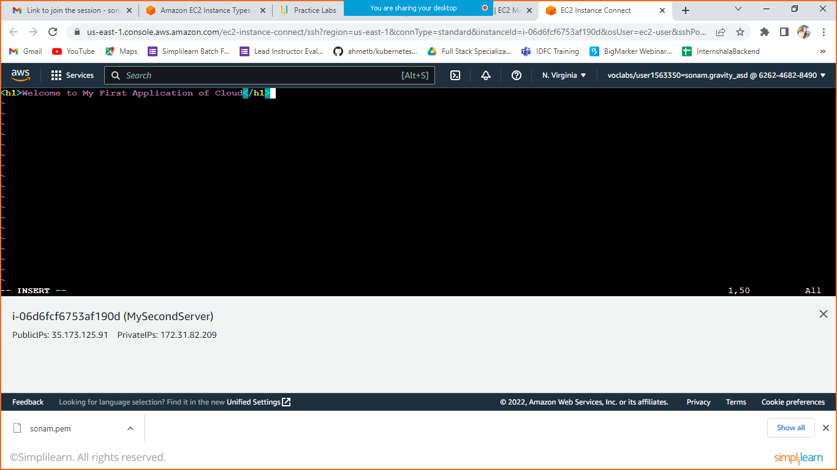

Press esc type :wq! Press enter.

File saved successfully.

Let’s start the HTTP server.

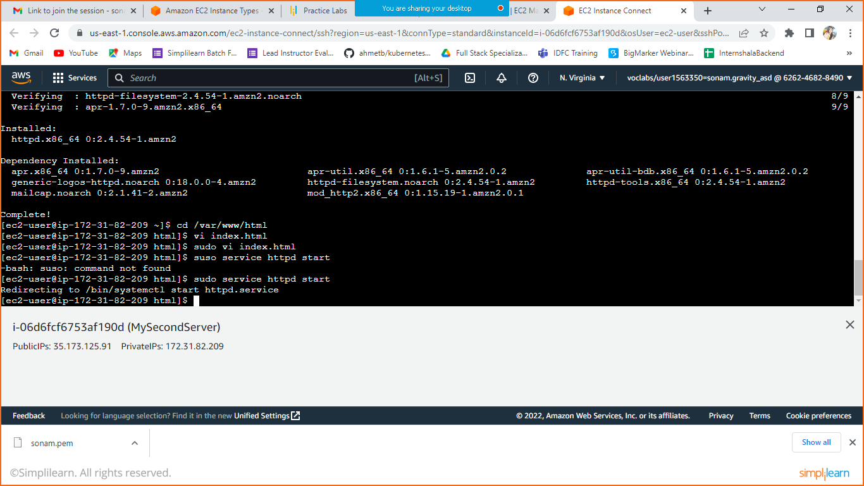

Once the service started go to your instance and check the public Ip and open that in your browser your can see the HTML file running live.

